 | QUARTERLY PHYSIOTHERAPY REPORT  Burton Manor, Brampton | Q1 2026: January to March 2026 | Confidential

KEY PERFORMANCE INDICATORS

59  Current Census  59 of 128 beds occupied  ↓ 2 from opening | 46.09%  On Active 1:1 Rx  Of 59 current residents  Strong coverage | 8  Deaths / Palliative  13.1% of opening census  High-acuity quarter | 92  Total Referrals  Q1 2026  Completed this quarter

70  Total Assessments  Q1 2026  Completed this quarter | 29,010  1:1 Therapy Min.  Direct therapy delivered | 3,500  Evaluation Min.  Assessment time | 54.5h  PTA Hours / Week  2 PTAs (1 FT + 1 PT) | 22.5h  PT Hours / Week  Mon, Tue, Thu  3 days / week

RESIDENT FLOW — Q1 2026

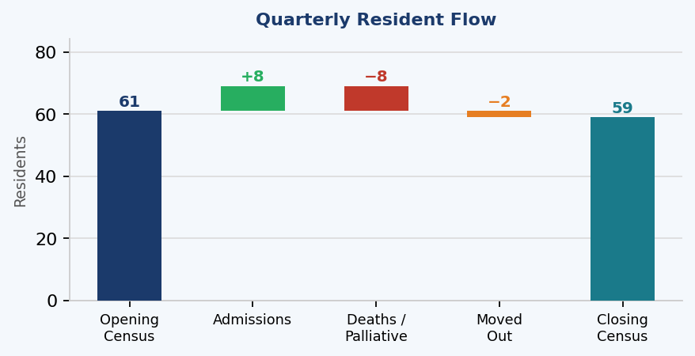 | 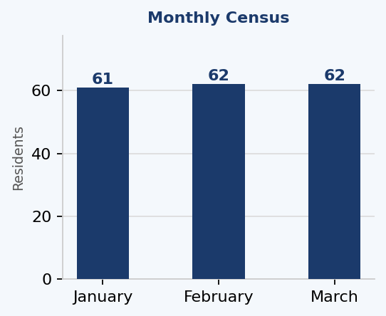

The quarter opened with 61 residents and closed at 59. 8 new admissions were received. 8 residents passed away or moved to palliative care (13.1% of opening census), and 2 moved out. Monthly census: Jan 61, Feb 62, Mar 62 residents.

PT REFERRALS AND ASSESSMENTS

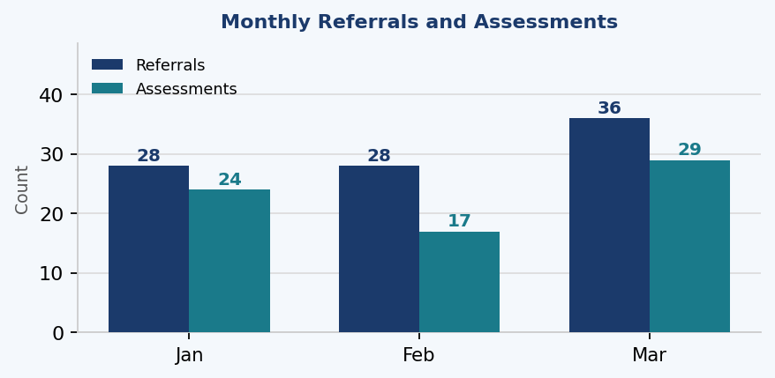 | Jan Feb Mar Total  PT Referrals 28 28 36 92  Assessments 24 17 29 70

PROGRAM MIX, THERAPY DELIVERY AND WORKFORCE

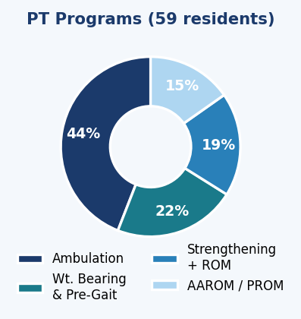 | 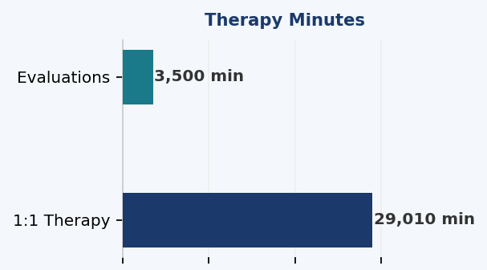  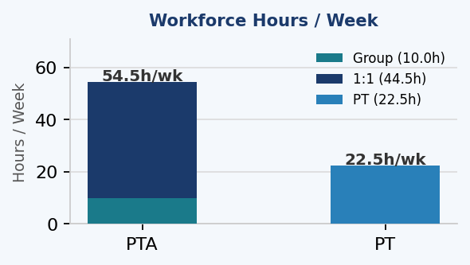

Ambulation 26 (44%), Wt. Bearing 13, Strengthening 11, AAROM/PROM 9 residents. | 29,010 min 1:1 therapy  3,500 min evaluations.  10 group sessions daily per floor. | PTA: 44.5h/wk 1:1 + 10.0h/wk group = 54.5h/wk total. PT: 22.5h/wk (Mon, Tue, Thu).

End of Report | Q1 2026 | Burton Manor Brampton | A & G Physiotherapy Inc.

